
COMSATS UNIVERSITY ISLAMABAD , ATTOCK CAMPUS

Computer Science Department

Bsse-6
Title: Airlines Management System

SUBMITTED TO:
DR. SADAF YASMEEN
SUBMITTED BY:
ZAINAB KHAN
(FA22-BSE-032)
MANAHIL TARIQ
(FA22-BSE-050)
ANUM HAMEED
(FA22-BSE-048)

INTRODUCTION:
Overview
The Airline Management System is a console-based application designed to streamline flight booking and management operations. It serves as a digital platform where users can register, log in, search for available flights, and book them efficiently. The system enhances user experience by offering a structured, interactive, and user-friendly interface, eliminating the need for manual booking processes. It also equips administrators with essential tools to manage and track flight operations effectively.
Purpose
The primary purpose of this system is to automate and simplify the airline flight booking process for both users and administrators. The system aims to:
- Provide seamless user registration and secure login mechanisms.
- Allow users to view and book flights from various departure locations.
- Enable basic administrative controls such as tracking and managing flight bookings.
- Ensure the system is secure, reliable, and easy to use for all types of users.
- Reduce human error and manual workload by digitizing flight operations.
Scope
The scope of the Airline Management System includes functionalities for both regular users (travelers) and administrators, covering the following features:
User-Side Scope:
- Account registration and login with email validation.
- Viewing available flights based on departure location.
- Booking flights by entering valid flight numbers.
- Receiving confirmation messages after successful bookings.
- Viewing booking history and logout functionality.
System Scope:
- Console-based interactive menu-driven interface.
- Data validation, secure session handling, and access control. Basic encryption and authentication mechanisms to safeguard user information. Support for scalability, maintainability, and system integrity.
SYSTEM ARCHTECTURE :
The Airline Management System follows a three-layered architecture to ensure modularity and separation of concerns. Below is the overall system architecture in textual form:
- Presentation Layer (User Interface - UI)
Technology Used: Java Swing
Responsibilities:
Handles user interactions for login, registration, flight booking, and viewing flights.
Provides a graphical interface for users to interact with the system.
Displays information such as available flights and booking confirmations.
- Application Layer (Business Logic)
Technology Used: Java (Core Logic)
Responsibilities:
Processes user authentication (login and registration).
Manages flight booking operations by checking flight availability.
Stores flight details, user data, and booking status in data structures (HashMap, ArrayList).
Ensures that business rules such as preventing duplicate user registration are enforced.
- Data Layer (Data Storage)
Technology Used: Java Data Structures (HashMap, ArrayList)
Responsibilities:
Stores user information (username, email, password) using HashMap.
Maintains flight details and schedules in an ArrayList.
Keeps track of booked flights and their availability status.
Simulates database operations by managing data in memory.
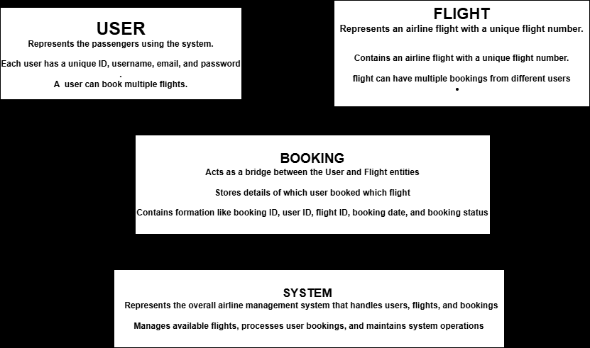
ARCHITECTURE DIAGRAM:
DETAIL DESIGN:
Module Descriptions and Responsibilities
Flight Module
Class Name: Flight
Responsibilities:
- Stores flight details (flight number, origin, destination, departure time, arrival time, and day).
- Maintains the booking status of the flight.
Attributes:
- int flightNumber – Unique identifier for the flight.
- String from, to – Source and destination of the flight.
- String departureTime, arrivalTime – Timings for the flight.
- String day – Day on which the flight is scheduled.
- boolean isBooked – Tracks booking status.
Methods:
Constructor to initialize flight attributes.
User Module
Class Name: User
Responsibilities:
Stores user information (username, email, and password).
Facilitates authentication for login.
Attributes:
String username, email, password – Stores user credentials.
Methods:
Constructor to initialize user attributes.
Main Application Module
Class Name: Main
Responsibilities:
- Provides the graphical user interface (GUI) using Java Swing.
- Handles user registration and authentication.
- Manages flight booking and displays available flights.
- Ensures secure access control by restricting booking to logged-in users.
GUI Components and Functionality
User Interface Elements
Frame: JFrame frame
Text Fields: JTextField usernameField, emailField
Password Field: JPasswordField passwordField
Text Area for Flights Display: JTextArea flightsArea
Buttons: JButton
- loginButton – For user authentication.
- registerButton – For new user registration.
- viewFlightsButton – Displays available flights.
- bookFlightButton – Allows a logged-in user to book a flight.
- logoutButton – Logs out the current user.
User Authentication
Registration Process:
- Takes user input (username, email, password).
- Checks if the username exists in the users HashMap.
- If not, stores the user and confirms registration.
- Login Process:
- Takes username and password.
- Checks credentials in the users HashMap.
- If correct, logs the user in and grants access to booking.

Flight Management
View Flights:
- Retrieves available flights from the flights ArrayList.
- Displays them in flightsArea.
Book Flight:
- Prompts user for a flight number.
- Verifies flight existence and marks it as booked.
- Confirms booking to the user.
Data Storage
- Users: Stored in HashMap<String, User> where the key is the username.
- Flights: Stored in ArrayList<Flight> containing all available flights.
System Flow
- Launch Application – Displays login/register screen.
- User Registration/Login – Handles authentication.
- View Flights – Lists available flights.
- Book a Flight – Requires login, confirms booking.
- Logout – Clears session, returns to login/register screen.

UML DIAGRAMS:
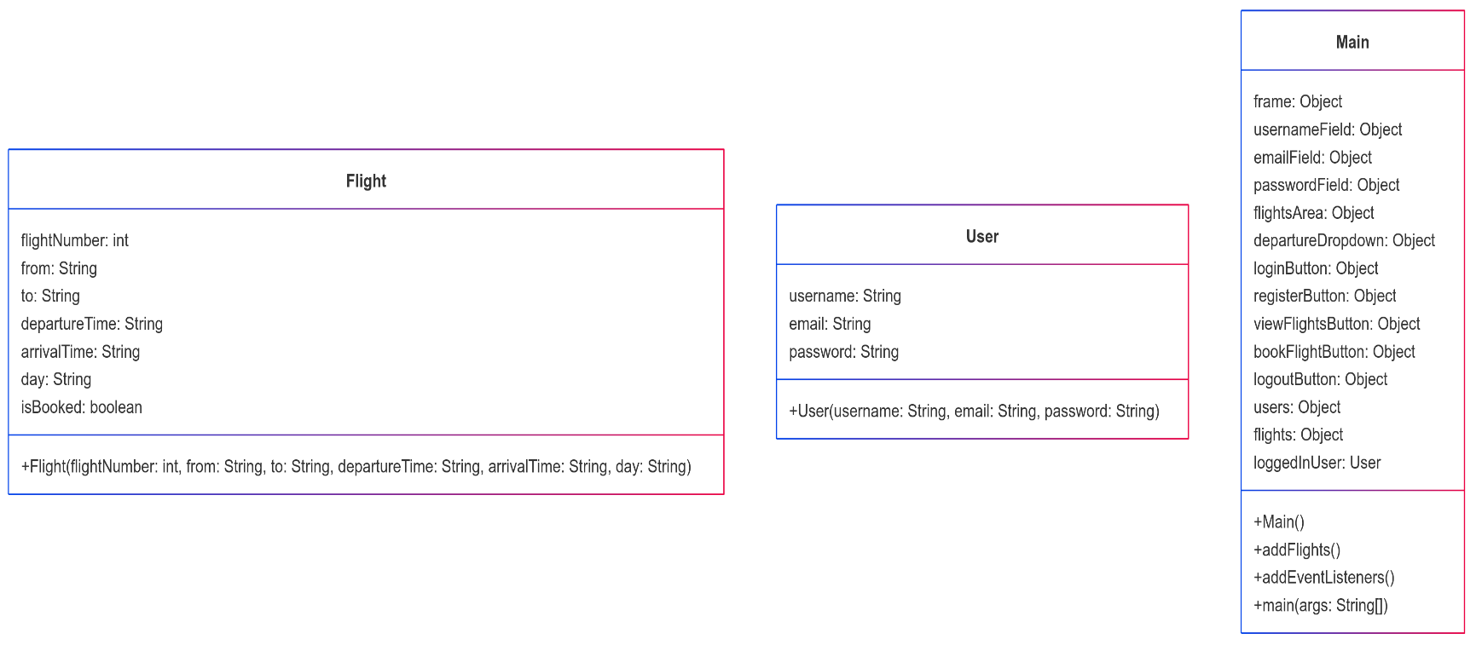
CLASS DIAGRAM:
SEQUENCE DIAGRAM:
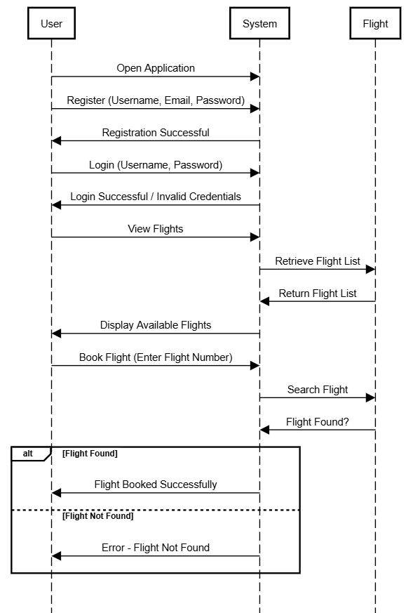
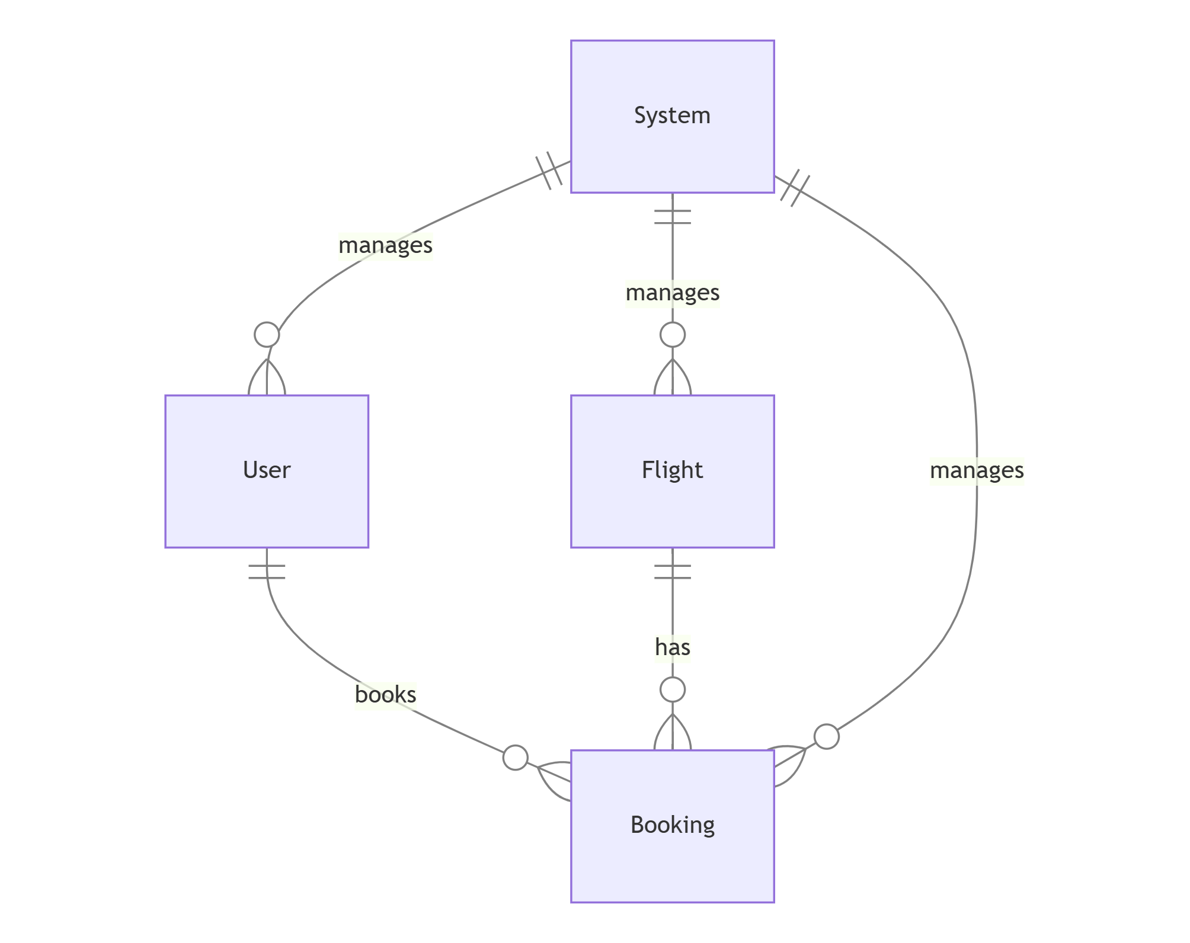
ENTITY RELATIONSHIP DIAGRAM (ERD):

REQUIREMENT MAPPING :
REQUIREMENTS | MAPPED DESIGN COMPONENTS
Users should be able to register and log in. | User class, registerButton action, loginButton action, users HashMap
Users should be able to view flights based on departure location. | viewFlightsButton action, flightsArea JTextArea, flights ArrayList
Users should be able to book flights based on available flights. | bookFlightButton action, Flight class (isBooked attribute), flights ArrayList
The system should validate email input during registration. | registerButton action, validation logic for email format before adding user to users HashMap
As an administrator, I want to track booked flights so that I can manage airline operations efficiently. | Enhancement needed: Admin interface to list booked flights (filter flights where isBooked = true)
As a registered user, I want to book a flight so that I can confirm my travel plans. | bookFlightButton event listener, flights ArrayList
As a user, I want to receive a confirmation message after booking a flight so that I know my booking was successful. | confirmation in bookFlightButton event listener
As a user, I want to be informed if I enter incorrect login credentials so that I can correct my mistake. | error message in loginButton event listener
AI TOOLS UTILIZATION SUMMARY :
AI tools played a significant role in the design generation and refinement of the Airline Management System by assisting in multiple phases of development, including structuring requirements, optimizing design, and improving implementation.
1. Requirement Analysis and Mapping
- AI facilitated requirement breakdown into functional components, ensuring each feature was mapped to a corresponding design element.
- Generated a requirement mapping table to align system functionality with implementation components, making the design more structured and traceable.
3. Logic and Feature Enhancement
- Recommended the implementation of an admin feature to track booked flights, improving system management.
- Proposed an enhancement for error handling (e.g., checking for duplicate registrations, invalid flight numbers).
DIAGRAM GENERATION:
Different AI tools assist a lot in generating UML diagrams in a correct manner. Some tools are mentioned below,
Marmaid AI
Eraser Diagram GPT
Note GPT
Helps in generating the UML diagrams like class diagram , sequence diagram and ER – digram (ERD) simply by taking plaintext or explanation of functions , features and design and generate diagrams as an output .

